Understanding z-scores
Z-scores are used to measure how many standard deviations a value is from the mean of a distribution. They provide a way to standardize scores on different scales, making it easier to compare data points from different distributions.

What is a Z-Score?
A z-score indicates how far and in what direction a value deviates from the mean of the data set. A positive z-score means the data point is above the mean, while a negative z-score indicates it is below the mean. The formula to calculate a z-score is:
z=x−μσz=σx−μ​
Where:
xx is the data point,
μμ is the mean of the distribution,
σσ is the standard deviation of the distribution.

Commonly Used Z-Scores
In the standard normal distribution, z-scores tell you how many standard deviations from the mean account for a certain percent of all data. You learned previously that:
- Within 1 standard deviation: about 68% of the data
- Within 2 standard deviations: about 95% of the data
- Within 3 standard deviations: about 99.7% of the data
You can also calculate how many standard deviations a value is from the mean, but what percentage of the data you can find within a certain interval. For example:
- 80% of the data: within 1.28 standard deviations
- 90% of the data: within 1.645 standard deviations
- 95% of the data: within 1.96 standard deviations
- 99% of the data: within 2.576 standard deviations
These two problems are inverses of each other.
These z-scores are the same for every normal distribution and you don't need to remember them by heart. Calculating z-scores is mathematically complicated. Virtually all practicing data analysts calculate the z-scores with a lookup table or a software like Google Sheets, using the NORM.S.INV function.
For example, to find the z-score under which 97.5% of the data falls, you would use:
=NORM.S.INV(0.975)

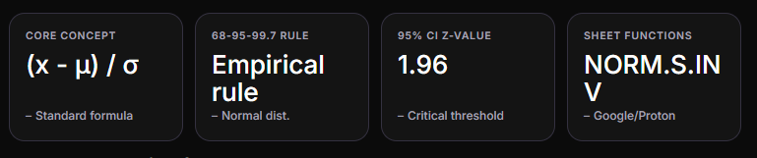
I can see you've uploaded "Understanding z-scores.docx" - this is a solid foundational document on z-scores and the standard normal distribution. Let me build on this with a deeper analysis, practical examples, and implementation guidance for both Google Sheets and Proton Sheets.
Core concept
(x - μ) / σ
–Standard formula
68-95-99.7 rule
Empirical rule
–Normal dist.
95% CI z-value
1.96
–Critical threshold
Sheet functions
NORM.S.INV
–Google/Proton

Deeper Analysis of Z-Scores

Conceptual Extensions Beyond the Document
Standardization Power: Z-scores transform any normal distribution into the standard normal distribution (mean=0, SD=1), enabling comparison across vastly different measurement scales. This is particularly valuable when comparing:
- Test scores from different exams
- Performance metrics across departments
- Financial indicators with different units
Outlier Detection: A practical extension not covered in the file is using z-scores for outlier identification:
- |z| > 2: Unusual observation (~5% tail)
- |z| > 3: Strong outlier (~0.3% tail)
- |z| > 3.5: Extreme outlier (flag for investigation)
Assumption Limitation: The document assumes normality, but real data often deviates. Consider:
- Skewed distributions require transformations or non-parametric methods
- Heavy-tailed distributions produce misleading z-scores
- Always verify normality with histograms or Q-Q plots before applying z-score logic

Practical Examples with Spreadsheet Implementation

Example 1: Student Performance Comparison
Imagine comparing a student's performance across two different exams:
Exam | Score | Class Mean | Std Dev | Z-Score
Math | 85 | 78 | 6 | 1.17
English | 92 | 88 | 4 | 1.00
Interpretation: Despite higher raw score in English, the student performed relatively better in Math (1.17 vs 1.00 SD above mean).
Google Sheets Formula:
=(B2-B4)/B5 // Where B2=score, B4=mean, B5=stddev
Proton Sheets Formula: Same syntax works in Proton Sheets — (C2-Mean!A1)/(StdDev!A1) referencing separate cells.

Example 2: Quality Control Threshold Setting
A manufacturing process produces parts with target length 10cm, observed variance ±0.3cm. What's the upper specification limit covering 95% of production?
Calculation:
Upper limit = μ + z(0.975) × σ = 10 + 1.96 × 0.3 = 10.588 cm
Spreadsheet Implementation:
// Google Sheets or Proton Sheets=10 + NORM.S.INV(0.975) * 0.3// Returns 10.588

Example 3: Percentile Ranking from Z-Score
If a candidate scores at z = 0.84, what percentile are they in?
Using inverse function:
=NORM.S.DIST(0.84, TRUE)// Returns ~0.7995 (79.95th percentile)
Or with NORM.S.INV working backwards:
=NORM.S.INV(0.90)// Returns 1.28 (90th percentile z-score)

Visualizing Z-Score Distribution

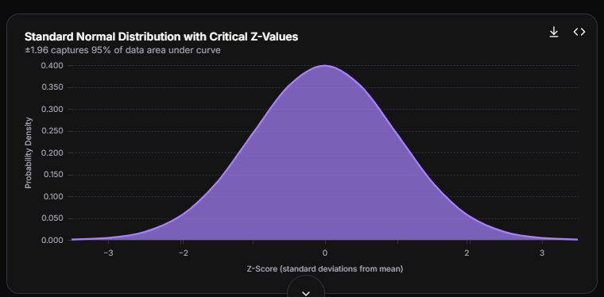

−3−2−2−101223Z-Score (standard deviations from mean)0.0000.0500.1000.1500.2000.2500.3000.3500.400Probability DensityStandard Normal Distribution with Critical Z-Values±1.96 captures 95% of data area under curve

Complete Spreadsheet Template

Google Sheets / Proton Sheets Structure
Here's a practical template structure you can implement:
Cell A1: "Raw Score" | Cell B1: "Mean" | Cell C1: "Std Dev" | Cell D1: "Z-Score"Cell A2: [input value] | Cell B2: [=AVERAGE(A2:A100)] | Cell C2: [=STDEV.S(A2:A100)] | Cell D2: =(A2-B2)/C2For percentile calculation in Cell E1:Cell E1: "Percentile"Cell E2: =NORM.S.DIST(D2, TRUE)*100For finding z-score from percentile in Cell F1:Cell F1: "Target Percentile"Cell G1: 0.95Cell G2: =NORM.S.INV(G1) // Returns 1.645 for 95th percentile

Proton Sheets Specific Notes
According to my Proton knowledge, Proton Sheets supports end-to-end encrypted spreadsheet collaboration at https://sheets.proton.me. The formula syntax mirrors Google Sheets for standard statistical functions:
Function | Purpose | Example
NORM.S.INV(probability) | Find z-score from cumulative probability | =NORM.S.INV(0.975) → 1.96
NORM.S.DIST(z, TRUE) | Find probability from z-score | =NORM.S.DIST(1.96, TRUE) → 0.975
NORM.INV(probability, mean, stddev) | Find raw value from probability | =NORM.INV(0.95, 100, 15)
STANDARDIZE(x, mean, stddev) | Calculate z-score directly | =STANDARDIZE(115, 100, 15) → 1.0

Advanced Use Case: Multi-Dataset Comparison
When comparing sales performance across regions with different scales:
Region | Avg Sales | Std Dev | Rep Score | Z-Score | Ranking
North | $50K | $8K | $62K | 1.50 | 2nd
South | $75K | $12K | $88K | 1.08 | 3rd
East | $40K | $5K | $55K | 3.00 | 1st
Without z-scores, South rep appears highest ($88K), but standardized scoring reveals East rep performs best relative to their region (3.0 SD above mean vs 1.50 for North).
Critical insightinfo
Z-scores enable fair comparisons across different scales but require verifying normal distribution assumptions. For heavily skewed data, consider rank-based percentiles instead.

Error Rate Visualization
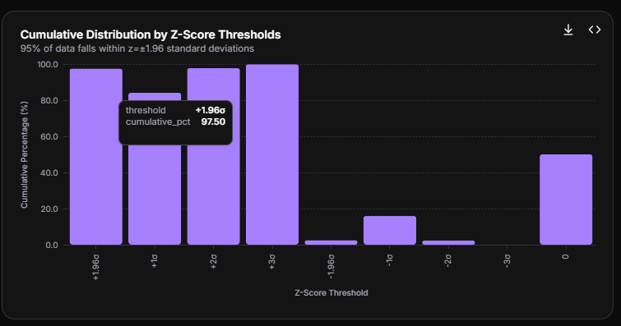

+1.96σ+1σ+2σ+3σ-1.96σ-1σ-2σ-3σ0Z-Score Threshold0.020.040.060.080.0100.0Cumulative Percentage (%)Cumulative Distribution by Z-Score Thresholds95% of data falls within z=±1.96 standard deviations
Implementation checklist
1) Verify normality with histograms; 2) Use STANDARDIZE() or manual (x-mean)/sd formula; 3) Apply NORM.S.INV/NORM.S.DIST for percentile conversion; 4) Set outlier thresholds at |z|>2 or |z|>3 based on tolerance; 5) Remember z-scores are symmetric around mean.
Would you like me to expand on any particular application area (e.g., financial risk assessment, medical reference ranges, or quality control limits)? I can also walk through building a complete interactive template for either Google Sheets or Proton Sheets.

